- Describe Static testing.
(Slide 3)
Static testing involves examining the system or test artifacts such as requirements or design documents without executing the code. This process checks the test object against source documentation to identify defects like incomplete requirements or non-compliance with specific standards, allowing testers to find errors and faults early in the development lifecycle.
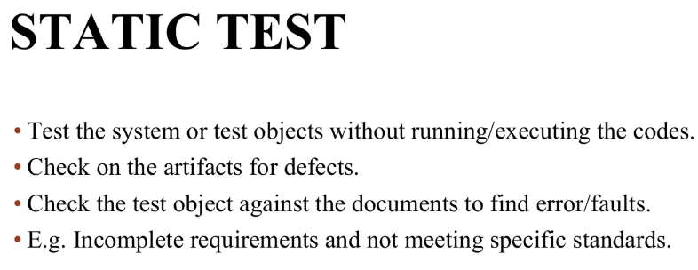

Criteria | Static Testing | Dynamic Testing
Definition | Testing that examines code, requirements, and design without executing the program. | Testing that involves executing the software to identify defects.
Performed at | Early stages of development (before code execution). | After code is developed and executed.
Focus | Defect prevention (verification) | Finding and fixing defects (validation)
Items to be tested | Assessment of code and artifacts (documentation) | Assessment of bugs/bottlenecks in the software system.
Methods Used | Reviews, walkthroughs, inspections, static analysis. | Functional and non-functional testing, such as unit testing, system testing, and acceptance testing.
Defect Detection | Identifies issues like syntax errors, logical flaws, and missing requirements early. | Detects runtime errors, performance issues, and security vulnerabilities.
Cost Efficiency | More cost-effective as it prevents defects before implementation. | More expensive since fixing defects post-development requires more effort.
Examples | Code review for security vulnerabilities, requirement document validation. | Running test cases to verify system behaviour under different conditions.
Importance | Helps ensure compliance with coding standards and best practices. | Ensures the software functions correctly in real-world scenarios.

- Describe three (3) advantages of Static testing?
Detect defects earlier (in the earlier stage of the SDLC when apply review)
Cheaper in term of cost
Provides more understanding of the system to be developed
Early Defect Detection
Issues like syntax errors, coding standard violations, and design flaws can be identified in the initial phases (requirements, design, and coding) before the code is even executed.

Cost and Time Efficiency
Fixing bugs in the early stages of the Software Development Life Cycle (SDLC) is significantly cheaper and less time-consuming than addressing them after deployment or during dynamic testing.

Reduced Risk
Catching potential problems proactively mitigates the overall risk of system failures and unexpected behavior in a production environment.

Enhanced Security
It helps identify potential security vulnerabilities and weaknesses in the code structure early on, reducing the risk of breaches later.
Detect defects earlier in the SDLC
static testing allow defects to be identified at very early stages of SDLC even before code is executed. Document reviews, walkthroughs and inspections help uncover issues in requirement, design documents and test plans. Team can prevent major rework, reduce project delay and improve overall software quality from the start by detecting defects early.

Cheaper in terms of cost
It is more cost effective to find and fix defects in early stages compared to later stages or after deployment. Corrections can be made with minimal effort during early stage as code design and documentation is still limited. This reduces effort for expensive fixes, reprogramming, reset sting or customer support efforts.

Provides better understanding of the system
Static testing help developer and testing team to gain a deeper understanding of the system before actual implementation begins. This ensures that everyone involved shares the same interpretation of the system. As a result, it minimises ambiguity, improve communication across teams and lead to better planning and more effective test case design.
- List and explain the types of Review.
Informal
Formal
Walkthrough
Inspection
Half marks only

Code Review: Evaluate the code structure together with the tester and check on the standard and procedures to ensure the consistency of code and compliance to the defined standard.

Desk Checking: It is the primary testing done on code before compilation or execution. The code will compare with requirements specification to make sure it meets the requirement.
Pair Programming: It is done by two programmers and they collaborate to write and test the code. One programmer controls the keyboard & mouse for writing the code. Another one reviews the written code.

Code Walkthrough: Normally done in a single meeting and less formal to find anomalies & improve the software product and evaluate the conformance to standard and specification. Testers and programmers use paper test cases for the program or module to be tested.

Technical Review: This team of qualified personnel examines the suitability of the software product for its intended discrepancies from the specification and standards point of view.

Formal Inspection: Formal inspection is a structured, rigorous review process used to detect defects in software artifacts (requirements, design, code, test cases) before execution. It is one of the most disciplined forms of static testing.

- List and describe the Review processes.[Refer to Chapter 3 Slide 8]
- Planning
- Decide which documents in the software development process shall be the subject to which review technique.
- Also forming the review team
- Kick-Off
- Sharing information about the document to be reviewed. Determine the significance and the objective of the planned review.
- Individual Preparation
- Reviewers study review objects.
- Check the review object against the documents and their own experience
- Check for any deficiencies and defects, obtain questions and also comments.
- Review Meeting
- Review meetings consist of a review leader or moderator to lead, participants should behave diplomatically and contribute to the review.
- The review meeting has a fixed time limit.
- The purpose of the review meeting is to decide whether the review object has met the requirements and complies with standards. Find defects if necessary.
- To know whether the document is accepted, or needs to be repaired or rewrote.
- Rework
- This stage would require the manager to decide to follow the recommendations or do something else with the document.
- Usually the author will eliminate the defects on the basis of the review result and rework the document.
- Follow Up
- Correction of defects will be followed up.
- If unacceptable, another review should be scheduled to check for changed areas based on what was discussed in the previous review meeting.

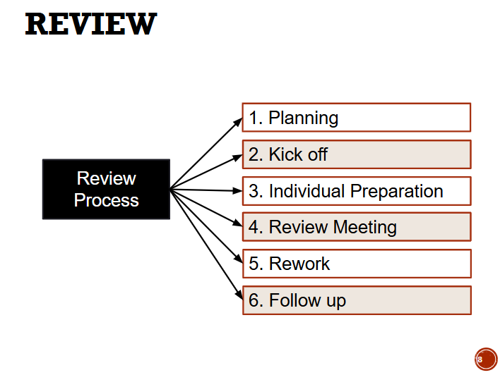

- When reviewing the requirement specification, what are the qualities of the requirement to be reviewed?
- Consistency
- Correctness
- Testability
- Completeness
Consistency
requirements in the document shouldn’t conflict or ddifferent description of the same functions.
Requirements should not contradict with other requirements. Each must fully comply with external documentation, as well as internal and external standards.

Correctness
each requirement must accurately describe the functionality to be built, the reference of correctness is the source of the requirement, such as an actual user or a high level system requirement. A software requirement that conflict with its parent system requirement is not correct.
All statements should be correct and truthful and make sense.
Testing a system against incorrect requirements is a waste of time and effort.

Test ability
there should be a way to check whether or not an implementation meets its requirement
Testable products are easy and less costly to maintain, and the changes of achieving customer satisfaction are much higher. That’s why testability is so important to the maintainability of the application.

Completeness
A requirement must contain all information needed for developers and everyone else who use it to do their jobs. Requirement should include all necessary details to express user needs
Using a heuristic testing approach in testing requirements that relies on past data about probabilities and it often allows for a more intelligent investigation of where bugs or problems might occur even in terms of requirements testing.

Clearness
requirements should be transparent and clear for everyone with only one interpretation possible.
Ambiguity occurs when several interpretations and plausible, any idea or statement intended meaning cannot be definitely resolved is ambiguous. But ambiguity also depends on the readers knowledge and expertise.

Limitations of static testing
Cannot detect runtime errors
Cannot identify issues that only appear when software runs. Performance issues and crashes/issues caused by interaction with hardware and external systems can only be caught through dynamic testing.

Consistent
Requirements should not conflict with each other.
Example of inconsistency:
- One requirement says the password must be 8 characters.
- Another says minimum of 12 characters.
- Both cannot be true at the same time.

Feasible
The requirement must be technically and financially achievable within project constraints:
- Budget
- Time
- Technology
- Resources

- Who are the participants in a Review and what are their roles?
- Manager
- Moderator
- Author
- Reviewer
- Scribe
- Moderator (review leader)
- Lead the review meeting to ensure discussion stays on topic and make sure everyone can express opinions.
- reviewers
- Carefully examine the document to identify defects, inconsistencies, and deviations from standards and provide comments and suggestions.
- Author
- The person who created the document and explains unclear parts.
- Manager
- Decides whether to accept, repair, or rewrite the document to ensure follow up is done properly.
- Specialists / experts
- Provide technical expertise and check compliance with standards and specifications.

- Imagine that you are the chairperson of a formal review, if there is conflict happening among the reviewers, how do you solve the conflicts between the reviewers?
- Understand the source of conflict
- Evaluate the impact of the cause
- Discuss and try to reach a consensus among team member
As chairperson, responsibility is to facilitate the review process and ensure it remains constructive. Here’s how conflicts can be handled:
Conflict Resolution Strategies
- Maintain Neutrality
  - Do not take sides.
  - Acknowledge both viewpoints to show fairness.
- Reinforce Review Objectives
  - Remind participants that the goal is to identify defects, not to debate personal preferences or assign blame.
  - Keep the focus on the artifact under review.
- Use Standards and Checklists
  - Refer to agreed coding standards, requirements, or review checklists.
  - This shifts the discussion from subjective opinions to objective criteria.
- Structured Discussion
  - Allow each reviewer to present their point without interruption.
  - Summarize the issue and ensure everyone understands before moving forward.
- Defer Unresolved Issues
  - If consensus cannot be reached during the meeting, log the issue for follow-up outside the review.
  - This prevents the meeting from being derailed.
- Promote Respectful Communication
  - Set ground rules: professional tone, no personal attacks, one person speaks at a time.
  - Intervene firmly if discussions become heated.
- Escalation if Needed
  - If the conflict persists, escalate to a technical authority or project manager for resolution.
  - Document the conflict and resolution path in the review report.

- Analyse the following pseudo codes/codes and perform desk checking on the changes of variable’s value:

Test Data for number is 2, 3, 1, 8, 10

BEGIN
Count = 0
Total = 0
REPEAT
Count = count + 1
Get number
Total = Total + number
UNTIL count = 5
Display Total
END

Count | Number | Total
0 | 0 | 0
1 | 2 | 2
2 | 3 | 5
3 | 1 | 6
4 | 8 | 14
5 | 10 | 24

- What are the limitations of Static testing?
Static testing does not give a complete picture of how the software behaves in a real environment. It cannot uncover runtime issues like performance bottlenecks, incorrect logic, memory leaks, System crashes or interruption issues. These defects can only be detected when code is ran through dynamic testing.

Static testing cannot determine whether the system meets user functional needs or behave correctly under real world conditions. It also cannot validate user experience factors such as responsiveness, usability, security under attack simulations or compatibility across different devices.

- Is Static testing alone sufficient to ensure software quality?

Different system different way of testing, agree?
Yes, different systems have different functionality to test and fulfil.
Different systems have different levels of complexity, simple web application only require functional and usability testing, banking needs rigorous security, performance and compliance testing.
Purpose of system influence methods, real time system requires stress and reliability testing, e commerce focus on load and usability testing,
Different technologies adapted require different test tools, api system need api testing, mobile apps require testing across device.
Regulatory requirements impact testing, healthcare and finance system must undergo compliance testing unlike general business application.
This testing approaches must be taller to fit system purpose, complexity, technology, industry standards to ensure reliable and high quality software.

